**Exploring the Effect of Alcohol Establishments on Crime in an Urban Community**

T. LaFrance, June 2020

**Background**

Urban planning in the United States can be roughly dated to 1682 when William Penn made it a point to incorporate Philadelphia as a planned city to serve as a port on the Delaware river. The laid out “grid” like structure of roads set a precedent in city planning and development. In 1811, NYC selected Central Park via eminent domain for use of the members of the community. In 1909, the first national conferences on city planning was held in Washington DC. More recently, in 1965, President Johnson formed the Department on Housing and Urban Development. These steps are centered around maintaining the quality of communities for present and future generations. In parallel with this concept, the number of community problems related to alcohol have been on the rise in the United States. In 1906, New Jersey became the first state to make driving a vehicle under the influence of alcohol a crime. Several states followed and the degree to which an individual was considered intoxicated varied from state to state and laws evolved over the years. In present day, where the number of vehicles has increased tremendously, impaired driving is a major cause of deaths. According to the Center for Disease Control and Prevention, 28% of traffic related deaths are related to drivers under the influence of alcohol. The concern might be that a large number of alcohol related establishments might exacerbate the number of incidents that result in harm due to inebriated persons. This is of consideration for the well-being of our communities and their development. Therefore, it is advantageous to study the effect of these establishments in the community. For example, this information can be used to plan police and local authority resources and help them target areas of the community that might be at risk.

**Problem**

The problem to be explored is the location of alcohol related establishments and the local area crimes. The distribution of businesses that are primarily related to alcohol, such as bars, nightclubs and retail alcoholic beverage markets should be understood. The proximity, frequency and type of crime is the information to be overlaid and evaluated with respect to the business locations.

**Data Availability and Sources**

The data needed fall into two regimes; one dataset related to location of the businesses of interest and one dataset related to the crimes and the locations of the crimes. For this pilot study, an urban area is likely to provide a good set of data. At first glance a city like New Orleans, New York, LA or Chicago might be ideal. Choosing the entire United States or all of those cities is not ideal as many states have jurisdiction over their crime records and they keep them in certain locations and formats. Some data seems to be available in reports and files for the US as a whole, but it is largely high level summary data and does not contain the level of detail needed.

The retail locations appear to be accessible using Foursquare for venue search to obtain type and location. Foursquare data has the advantage of being easily plotted on maps. One concern about Foursquare might be that some venues might be classified in a way that is not helpful for our analysis. For example, a country club that serves substantial amounts of alcohol might not be captured as a retail alcohol location.

The crime incidents and locations appear to be accessible in datasets that are available as court “Open Records” in the county in which the crime was committed. A quick survey of a few of these indicates these datasets are retrievable as .json or other formats and a description of what fields are in each dataset is usually available. Previewing some of these gives some insight; some datasets list the incident, the date, time, arresting officer, and a plethora of other information, but not details about the crime. Other data sets give the crime in a description field, but only give a general geographic location or an X, Y co-ordinate which is not helpful. Some had a street address, but the majority of the address fields had NaN values. These present a problem for the information sought, but so many datasets are out there that one will be found to contain functional information.

Focusing on a certain year or a recent few years will likely seem appropriate to control that amount of data. It will have to be explored as to whether all crimes should be looked at or if they could be filtered to those that are most related to alcohol. This is not completely straightforward either as, in recent years, the terms for intoxicated drivers are a multitude; DUI, DWI, OVI, OWI and sometimes other terms are used.

**Data Utilization**

The expectation is to retrieve data for alcohol related establishments for the city/urban area in question from Foursquare and plot these locations on a Folium map. The second part of the analysis is to pull crime data and locations from a relevant county crime dataset in the selected city/urban area and plot that on a Folium map. By combining information from these two sources, a visualization is expected that will allow the user to look for trends and investigate specific regions and make some suggestions for areas that are at greater risk for criminal activity, possibly induced by alcohol.

**Sources of Relevant Information**

<https://www.cdc.gov/motorvehiclesafety/impaired_driving/impaired-drv_factsheet.html>

<https://ucr.fbi.gov/crime-in-the-u.s/2016/crime-in-the-u.s.-2016/tables/table-18>

<https://crashstats.nhtsa.dot.gov/Api/Public/ViewPublication/812450>

**Methodology**

The Foursquare data was examined for a few different cities as noted. Most cities provided significant data. The radius and limit of how much data were a few parameters to play with, as well as the center point of the city. As typical of Foursquare data, several columns of unneeded data are pulled with the query, so the dataframe has to be cleaned up to show only the relevant information about the venue and location. A sample of the data before cleaning is shown below. The city selected is Los Angeles, centered around Union Station.

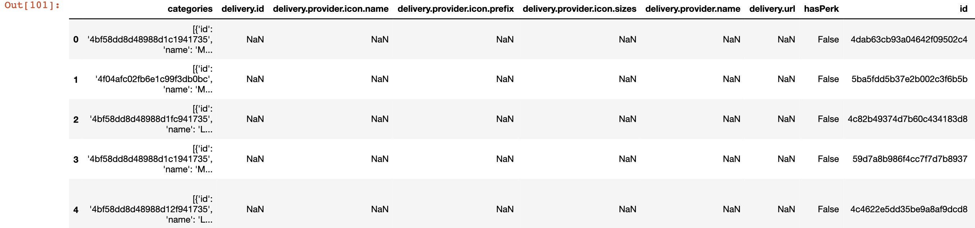

Here is the same location data from Foursquare shown after some cleaning steps:

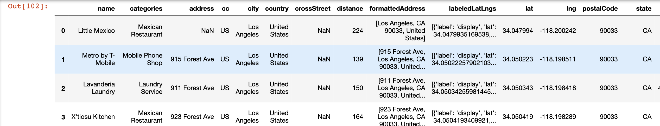

The Crime data also had to be examined for quality of information. As noted, not all crime reports indicate the crime in a uniform way. Often the type of crime is undecided at the time of arrest or mentioned in a description field. After previewing some data, it was clear that some NaN values would have to be filtered and the number of years of data would be constrained as the crime data set contained a history of many years. Shown below is the crime data before filtering. It is centered around Union Station in Los Angeles.

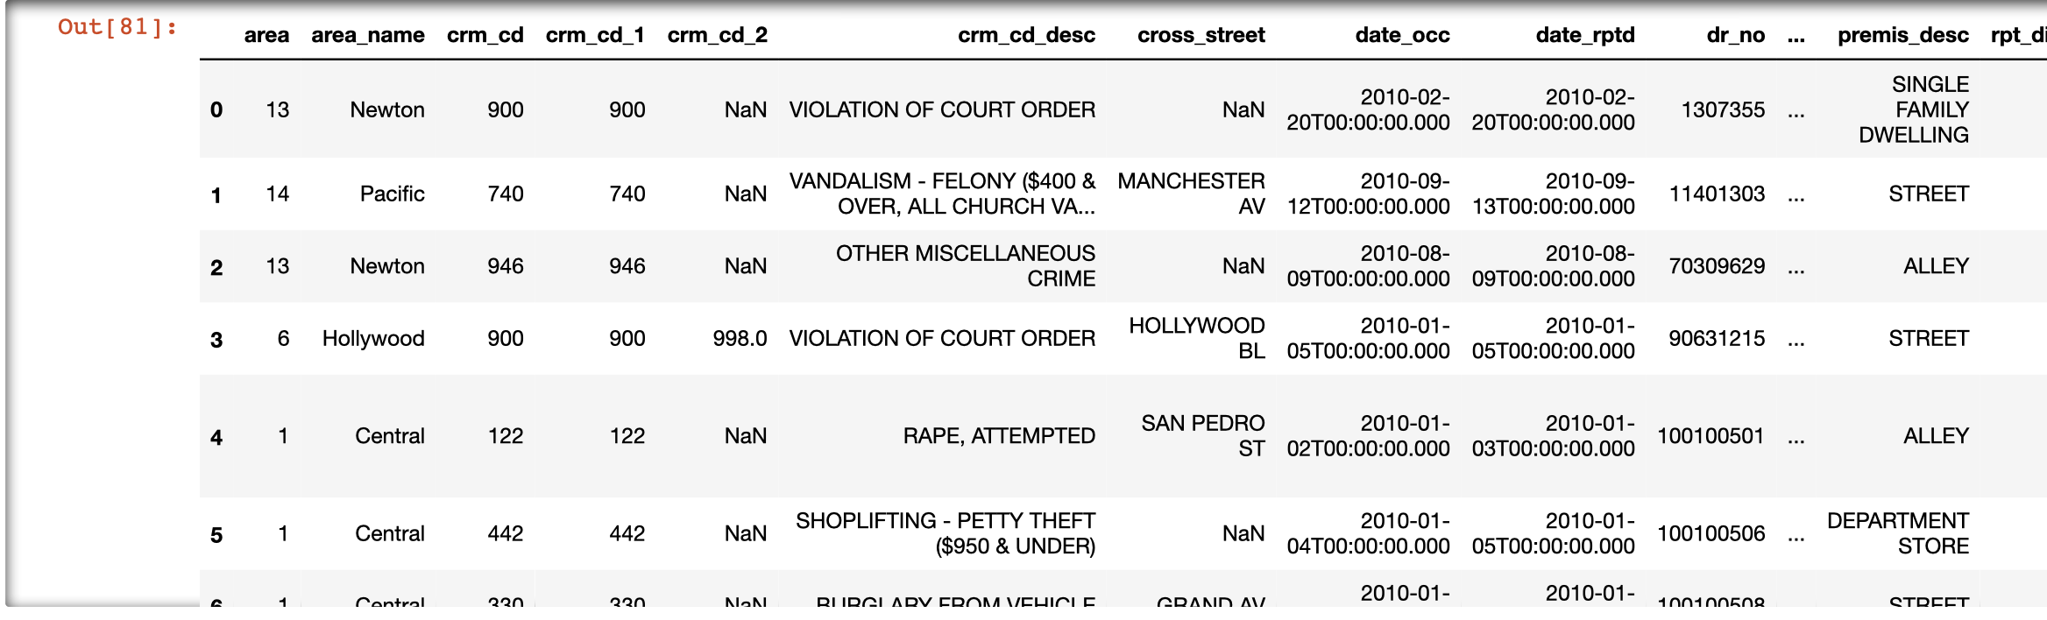

Here is a sample of the crime data after filtering for NaN and dropping unneeded columns.

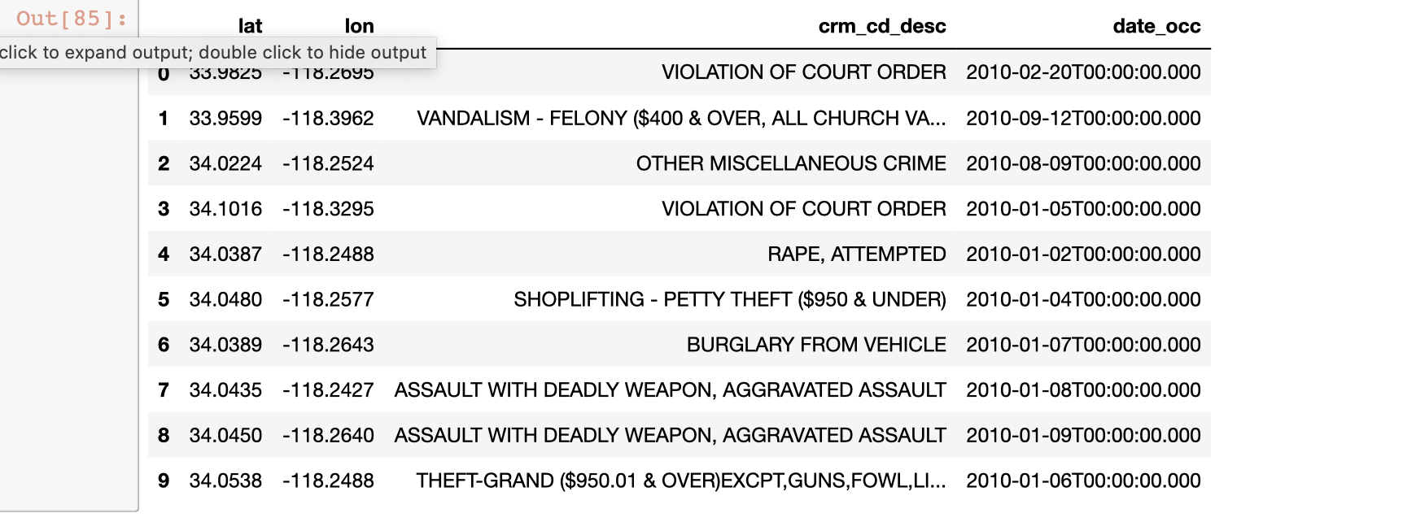

With both sets of data ready for visualization, a map of each is created. Parameters on the zoom level had to be experimented with as the distribution of data for the venues and crimes presented differently.

**Results**

Below are a few screenshots of the folium maps of the venues data. As you can see, there are some alcohol establishments clustered along a few main roads in the city and it would be an interesting study to correlate crimes along or near those same areas. If appropriate, I would suggest testing for statistical significance of frequency of crime in these areas compared to frequency of crime in a similarly populated area with fewer alcoholic establishments.

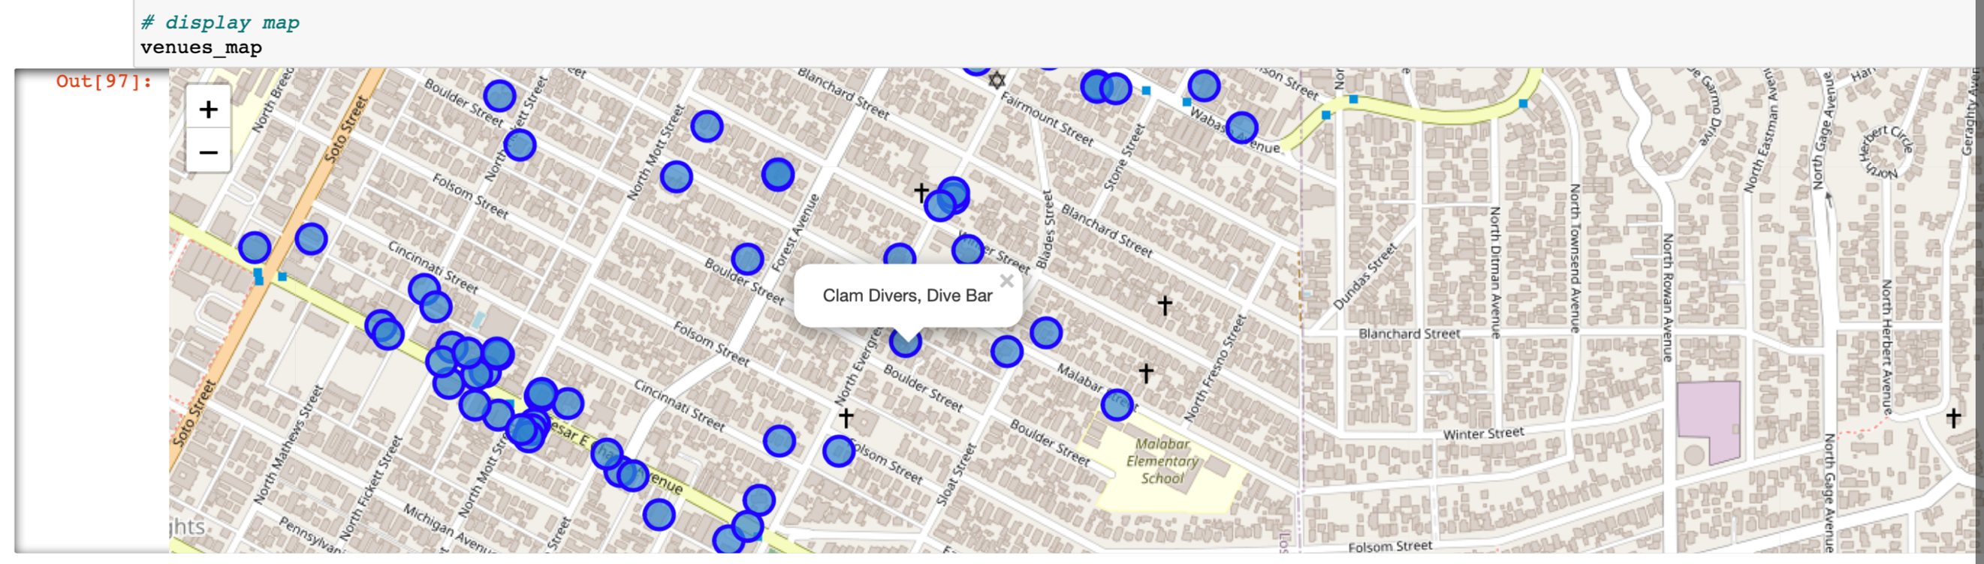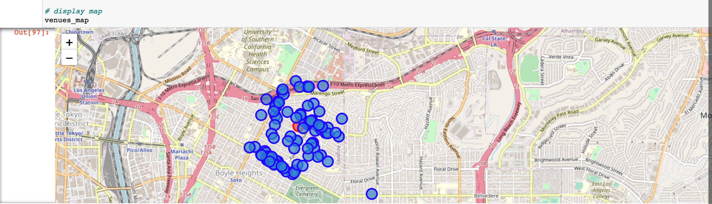

The information for the crime dataset is similarly plotted below at two different zoom levels. One observation is that the data for the crimes falls in a rather gridlock manner. This is likely due to officers reporting the location to the nearest block (ie. 3300 block of 5th street). This may not affect the outcome of the analysis, but if future work were to be done with other datasets, it is recommended to look for crime data that has street address locations tied to the incident record. Some cities did include specific street addresses although this data also had NaN values to contend with.

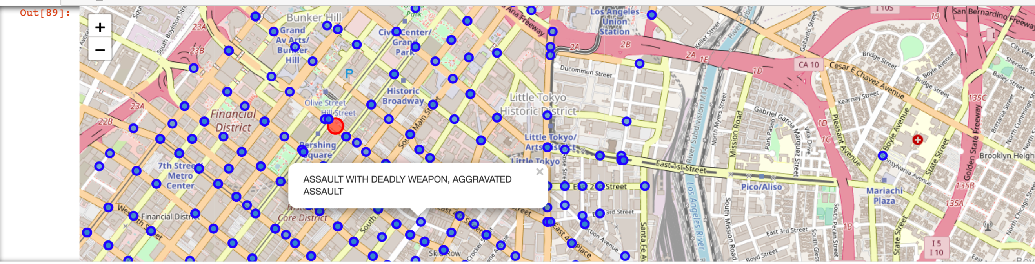

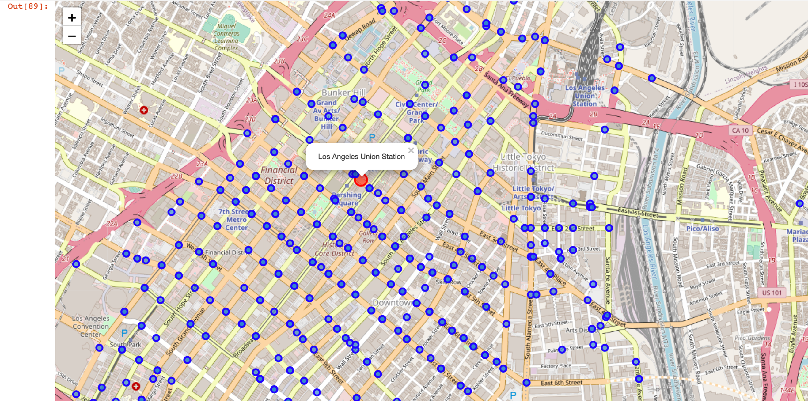

**Conclusion**

Based on the results, the visualizations do not identify any trends that would suggest an area with bars, nightclubs and alcohol retail markets has more crimes than any other part of downtown Los Angeles. It seems that crime records exist on nearly every block. If recommending further study on a similar topic, it might be good to isolate the crimes to DUI, DWI, OVI and OWI. This would take some additional steps while processing the crime data or perhaps searching for a data set that was purely based on DWI convictions. This might be available on a county, state specific basis by accessing court records. It also might be good to use a city such as New Orleans and create a similar visualization during an ordinarily month and the Mardi Gras month and compare the crime statistics in that manner. A comparison of New Orleans to a “sister city”; one if similar population might also yield some insights. As note prior, this information would be helpful in possibly adjusting the number of alcohol permits within a city’s limits and in planning policy resources around those areas which may have higher risk.